**PROJECT PHASE 2**

PROJECT MEMEBERS:

-SURAJ MANDAL

-VENKATA NARASIMHA VEDAVYAS MUPPAVARAPU

AS REQUESTED PROFESSOR IN CLASS, REAGRDING THE USAGE OF FIREBASE FOR PROJECT, THERE WONT BE ANY INSERT STATEMENTS AND OUTPUTS FOR FOLLOWING TABLE SCRIPTS AS PER THE RUBARICS. WE WILL SHOW YOU THE JSON STRING AS REQUESTED IN NEXT LAB WITH FURTHER DEVELOPMENT.

PLEASE FIND THE DETAILS BELOW OF ERD AND SCRIPTS.

* ER DIAGRAM

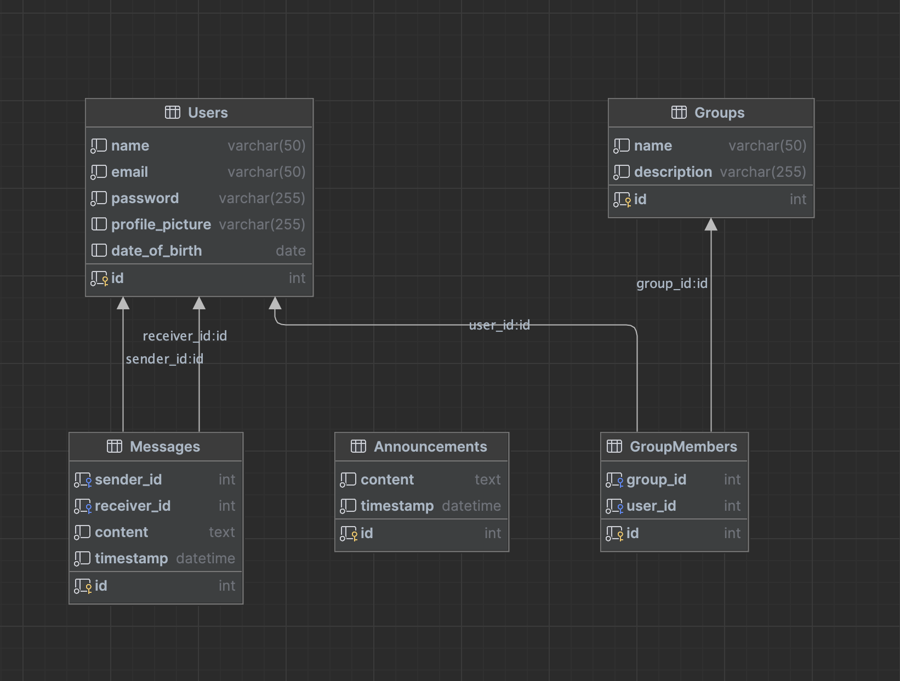

SCRIPTS:

**Users:** This table will store user information, including their name, email, password, profile picture, and date of birth.

CREATE TABLE Users ( id INT(11) NOT NULL AUTO_INCREMENT,

name VARCHAR(50) NOT NULL,

email VARCHAR(50) NOT NULL,

password VARCHAR(255) NOT NULL,

profile_picture VARCHAR(255),

date_of_birth DATE,

PRIMARY KEY (id),

UNIQUE KEY (email) );

**Messages:** This table will store direct messages sent between users. It will include the sender and receiver's user ID, the message content, and the timestamp.

CREATE TABLE Messages ( id INT(11) NOT NULL AUTO_INCREMENT,

sender_id INT(11) NOT NULL,

receiver_id INT(11) NOT NULL,

content TEXT NOT NULL,

timestamp DATETIME NOT NULL DEFAULT CURRENT_TIMESTAMP,

PRIMARY KEY (id),

FOREIGN KEY (sender_id) REFERENCES Users(id),

FOREIGN KEY (receiver_id) REFERENCES Users(id) );

**Groups:** This table will store information about each group, including the group name and description.

CREATE TABLE Groups ( id INT(11) NOT NULL AUTO_INCREMENT,

name VARCHAR(50) NOT NULL,

description VARCHAR(255) NOT NULL,

PRIMARY KEY (id) );

**GroupMembers:** This table will store the relationship between groups and their members. It will include the group ID and the user ID.

CREATE TABLE GroupMembers ( id INT(11) NOT NULL AUTO_INCREMENT,

group_id INT(11) NOT NULL,

user_id INT(11) NOT NULL,

PRIMARY KEY (id),

FOREIGN KEY (group_id) REFERENCES Groups(id),

FOREIGN KEY (user_id) REFERENCES Users(id) );

**Announcements:** This table will store announcements created by admins. It will include the announcement content and the timestamp.

CREATE TABLE Announcements ( id INT(11) NOT NULL AUTO_INCREMENT,

content TEXT NOT NULL,

timestamp DATETIME NOT NULL DEFAULT CURRENT_TIMESTAMP, PRIMARY KEY (id) );